Otherwise
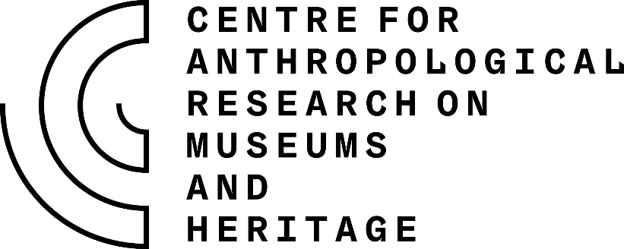

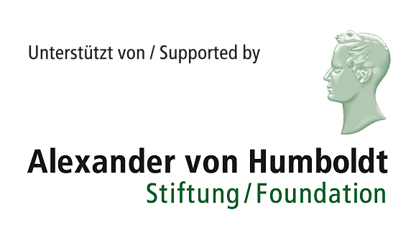
Rethinking museums and heritage

An international conference

Centre for Anthropological Research
on Museums and Heritage (CARMAH)

Application form

Name
Address
Email
Title of PhD
University affiliation for PhD
Full-time or part-time
Start date for PhD
Year of (anticipated) completion
Previous degrees
(date and place completed)
Relevant experience for conference
(up to 250 words)
Relevant publications
(up to three)
Abstract (up to 250 words)

