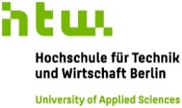
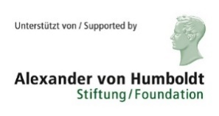
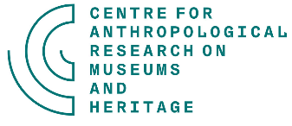
On Common Grounds?
Researching Public Engagements of Museums and Heritage Sites

An international workshop organised by
Centre for Anthropological Research
on Museums and Heritage (CARMAH)

and

Hochschule für Technik und Wirtschaft Berlin (HTW)

Please send this application to gramrikk@hu-berlin.de no later than July 23rd, 2018.

In case of questions, please don’t hesitate to contact the organisers:
Rikke Gram (gramrikk@hu-berlin.de) and
Christine Gerbich (christine.gerbich@hu-berlin.de)

Application form

Name
Address
Email
(Working) Title of PhD
or,
if you do applied research (e.g. evaluation, artistic research): project title
Institutional affiliation

Start date for (PhD) project
Previous degrees
(date and place completed)
Relevant experiences for workshop
(up to 250 words)
Relevant publications
(up to three)
Motivation for participation (up to 250 words)

